

Lab 3
CSC308: Operating Systems
Spring 2025-26

Objective and Overview |  | Marks: out of 5
Grading Rules - rubric |  | Individual Submission
- Evaluation Criteria:  - Correctness and clarity:  - The answer is correct and has no factual mistakes.  - The answer is explained with clear language and is supported by illustrating examples whenever necessary.  - Accuracy of the results:  - Conducting proper experimental steps.  - Correct Explanation of the results  - Screenshots of the setup and results  - Critical analysis  - Justifications and reasoning are logical and supported by logical arguments.  - The student makes reflections from his/her own opinion whenever necessary.  - Format  - The report is properly formatted using consistent font size/style, consistent alignment, page numbers, captions, and headers.  - Proper citation and referencing is applied wherever appropriate. |  | Folds: 3.5 Marks  Video Demo: 1.5 Marks
Submission Guidelines
- Submit in Word or PDF format of the report along with the source code on Blackboard.
- All terminal output screenshots in the report must show your student ID. Failure to do so will result in a penalty of one mark.
- Include screenshots of all steps completed in each task.
- Record a 4-5-minute video with a voiceover explaining your work, upload it to OneDrive, and share the link in your report.
- Include the front page with all the details (Course description, student ID, name, etc.)
- This is an individual assignment.
- Due on May 22, 2026 – late submissions will be penalized (5% for each day).
- Reports will be scanned for similarity, and high similarity scores will be penalized.

Lab3- Multithreading

Threads in modern operating systems are used as a mean of improving the efficiency of the programs and avoiding lags in performance. Most modern operating systems provide threading support through thread libraries. Several programming languages also offer built-in or library-based support for multithreading, including C (pthreads), C++ (std::thread), Java (java.lang.Thread), Python (threading module), C# (.NET threading), Go (goroutines), and Rust (std::thread). These libraries enable developers to incorporate concurrency into their programs, thereby improving responsiveness and overall performance.
In this assessment, you are required to demonstrate the use of threading by developing a multithreaded file processing system and comparing its performance against a non-threaded implementation.
You are required to use the provided large text file:
LargeFile.txt
The assessment consists of three folds.
Fold 1: Using Threads (Implicit and Explicit Threading)
You are required to write a program in C that processes a large text file using both implicit threading and explicit threading.
The program should operate on the file provided on Blackboard.

LargeFile.txt

- Implicit Threading

You are required to use implicit threading to process the file simultaneously. The implicit threading part must:
- Open the provided large text file.
- Allow OpenMP to distribute the workload among available threads.
- Each implicit thread should:
- Count the number of lines.
- Count the number of words.
- Count the number of vowels.
- Display how many threads are running.
- Exit once the processing is completed.

-------------------------
It is permitted to use another programming language such as Java or Python. However, appropriate alternatives to OpenMP must be used to implement implicit threading in the chosen language.
- Explicit Threading
Use four explicit threads to perform the following operations.
- Divide the work
- Calculate how many lines each thread should process:
workload = total_lines /4
- Each thread should handle only its assigned portion of the file (not the whole file).

- What each thread must do
Each thread should:
- Find the longest word in the assigned file portion.
- Count the number of uppercase letters in the assigned portion.

Each thread must:
- Display its thread ID.
- Process only its assigned portion.
- Return partial results to the parent thread.
- Exit once it completes execution.

- Parent / Main Thread
The parent thread must:
- Display its thread/process ID.
- Reading the large file.
- Invoke a method responsible for:
- Method 1: Performing the implicit threading task
- Determining the workload size based on the total number of lines.
- Allowing the implicit threading mechanism to automatically distribute the workload among the available threads.
- Returning the total number of lines, words, and vowels.
- Method 2: Performing the explicit threading task
- Launching four explicit child threads.
- Finding the longest word.
- Counting uppercase letters.
- Returning the partial results to the parent thread.
- Compute the final results by:
  - Finding the total number of lines.
  - Finding the total number of words.
  - Finding the total number of vowels.
  - Finding the longest word in the file.
  - Finding the total number of uppercase letters.
- Display the final output.
- Display the total execution time.
If you are using C, please add -fopenmp -lpthread : gcc -o Program Program.c -fopenmp -lpthread// Add time to record the time of execution--> time ./a.out 1 3 4
Requirement 1
Analyze the performance of the threaded program.
You must:
- Monitor CPU/core usage using System Monitor or Activity Monitor.
- Measure the execution time of the program.
- Verify that some of the calculations are correct.
- Include screenshots showing:
  - Program execution.
  - CPU/core usage.
You should also briefly explain:
- How threads improved performance.
- Whether all CPU cores were utilized.
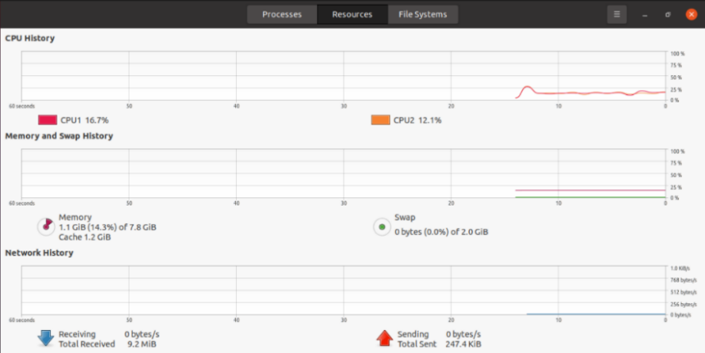
- Any challenges faced during implementation.
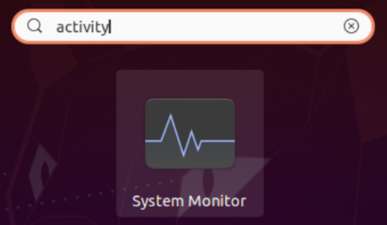

Fold 2: Using Only Implicit Threading
You are required to implement a version of the program using only implicit threading (e.g., OpenMP), without using explicit thread libraries such as pthread. The program must process the same input file (LargeFile.txt) and perform all computations concurrently using OpenMP. Use OpenMP to automatically parallelize the computation. The program must:
- Allow OpenMP to distribute the workload among available threads.
- Display the number of threads used.
Each thread should contribute to computing:
- Total number of lines
- Total number of words
- Total number of vowels
- Total number of uppercase letters
- Longest word in the file
Requirement 2
Analyze the performance of the non-threaded program. You must:
- Monitor CPU/core usage using System Monitor or Activity Monitor.
- Measure the execution time.
- Include screenshots showing:
  - Program execution.
  - CPU/core usage.
Fold 3: Without Threads
You are required to write another version of the program WITHOUT using threads. The program must process the same file sequentially and perform the same operations:
- Count the number of lines.
- Count the total number of words.
- Count the total number of vowels.
- Find the longest word.
- Find the total number of uppercase letters.
The program should also:
- Display the execution time.
- Display the final results.

Requirement 3
Analyze the performance of the non-threaded program. You must:
- Monitor CPU/core usage using System Monitor or Activity Monitor.
- Measure the execution time.
- Include screenshots showing:
  - Program execution.
  - CPU/core usage.

Requirement 4
Compare the results obtained from Fold 1, Fold 2 and Fold 3. Your comparison must include:
- Difference in execution time.
- Difference in CPU/core utilization.
- Advantages of multithreading (Implicit and Explicit Threading).
- Any disadvantages or overhead caused by threading.
- A plain-English explanation discussing why the threaded version performed better or worse.

